Two dimensional array:
An array with several rows and columns is called 2 dim array. Array with two subscripting operators [ ] [ ]
It is n*n matrix.
It is implicit double pointer.
It is array of array i.e. collection of one dim arrays.
Syntax: datatype var[rows][cols]={elements};
eg: int a[2][3]={{10,20,30},{40,50,60}};
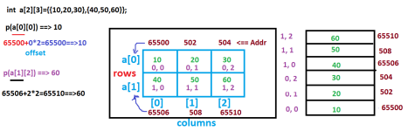In two dimensional array the rows/first subscript is working as array of pointers and they stores first column address of each row. Hence it is an implicit/internal double pointer.
In the above example, To print the first row, first column value, we have to use
printf(“%d”, a[0] [0]); 🡺 10
Internally how this statement is working ?
a[0] means value at a[0] i.e. 65500. Index no
65500 + [0] col 🡺 65500 + 0 * 2 🡺 65500 🡺 value at 65500 is 10.
Int size
Finding two dim array size:
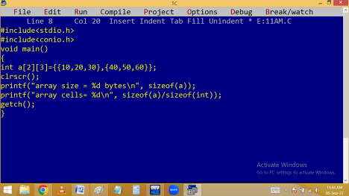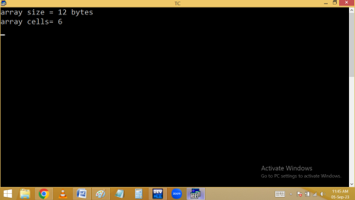
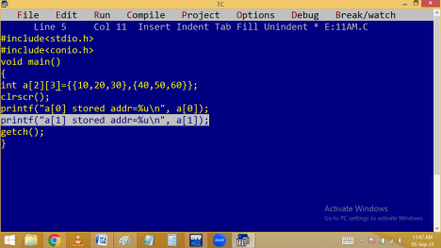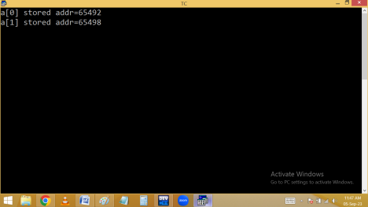Finding array cell element, position , address:
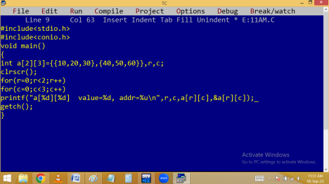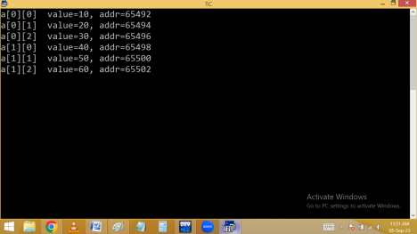
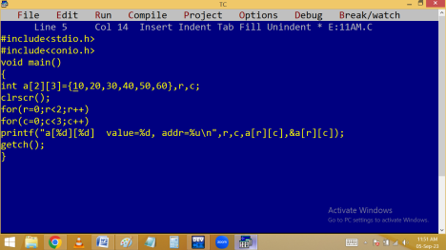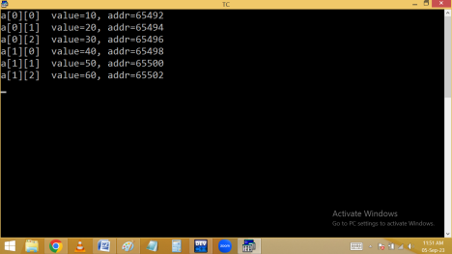
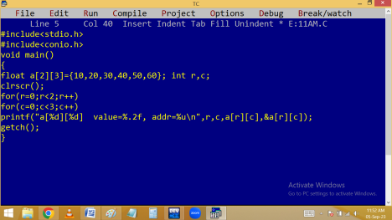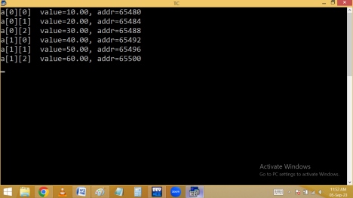
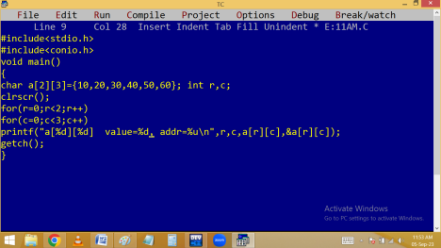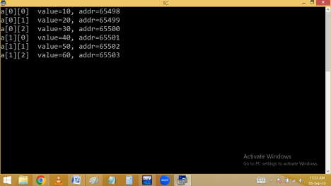Direct initialization of n*n matrix:
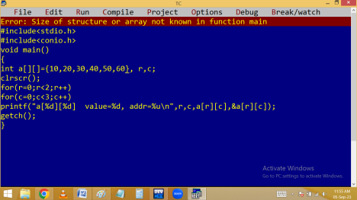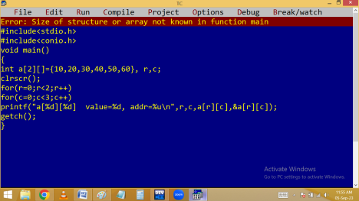
Reading and printing elements of n*n matrix:
Finding row sum of n*n matrix:

